**EXPERIMENT-1**

**CONFIGURATION OF NETWORK COMPONENTS**

**Aim:** To Study the following Network Devices in Detail

* PC
* Server
* Repeater
* Hub
* Switch
* Bridge
* Router
* Gate Way
* Transmission medium

**Apparatus (Software): CISCO Packet tracer**.

1. Node: In a communications **network**, a **network node** is a connection point that can receive, create, store or send data along distributed **network** routes.

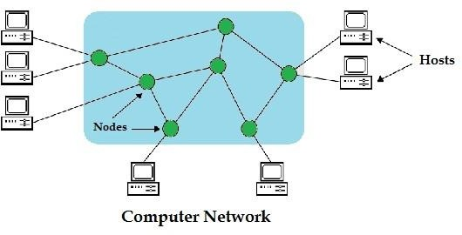

1. **Repeater:** Functioning at Physical Layer.

A **repeater** is an electronic device that receives a signal and retransmits it at a higher level and/or higher power, or onto the other side of an obstruction, so that the signal can cover longer distances.

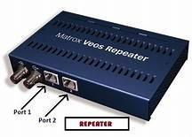 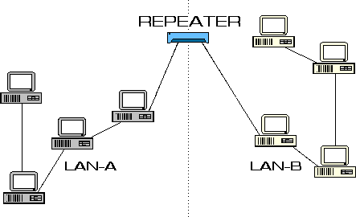

1. **Hub: Ethernet hub**, **active hub**, **network hub**, **repeater hub**

Hub or concentrator is a device for connecting multiple twisted pair or fiber optic Ethernet devices together and making them act as a single network segment. Hubs work at the physical layer (layer 1) of the OSI model. The device is a form of multiport repeater. Repeater hubs also participate in collision detection, forwarding a jam signal to all ports if it detects a collision.

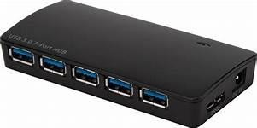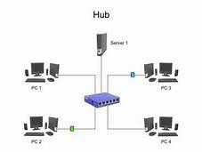

1. **Switch:** A **network switch** or **switching hub** is a computer networking device that connects network segments. The term commonly refers to a network bridge that processes and routes data at the data link layer (layer 2) of the OSI model. Switches that additionally process data at the network layer (layer 3 and above) are often referred to as Layer 3 switches or multilayer switches.

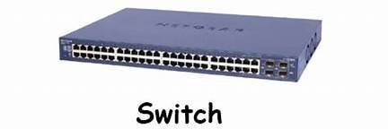

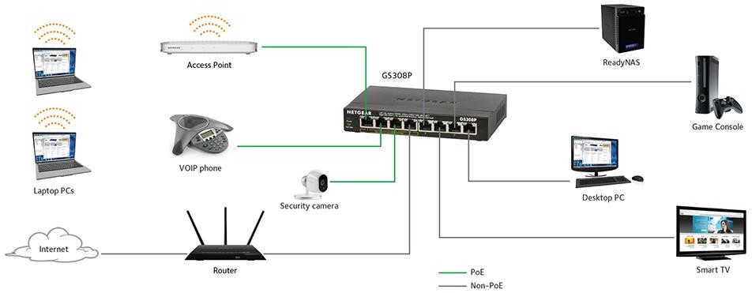

1. **Bridge:** A **network bridge** connects multiple network segments at the data link layer (Layer 2) of the OSI model. In Ethernet networks, the term bridge formally means a device that behaves according to the IEEE 802.1D standard. A bridge and switch are very much alike; a switch being a bridge with numerous ports. Switch or Layer 2 switch is often used interchangeably with bridge. Bridges can analyze incoming data packets to determine if the bridge is able to send the given packet to another segment of the network.

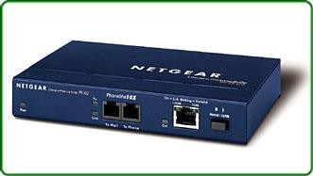

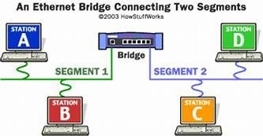

1. **Router:** A **router** is an electronic device that interconnects two or more computer networks, and selectively interchanges packets of data between them. Each data packet contains address information that a router can use to determine if the source and destination are on the same network, or if the data packet must be transferred from one network to another. The multiple routers are used in a large collection of interconnected networks, the routers exchange information about target system addresses, so that each router can build up a table showing the preferred paths between any two systems on the interconnected networks.

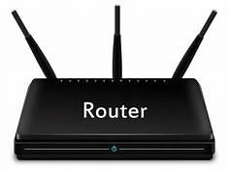

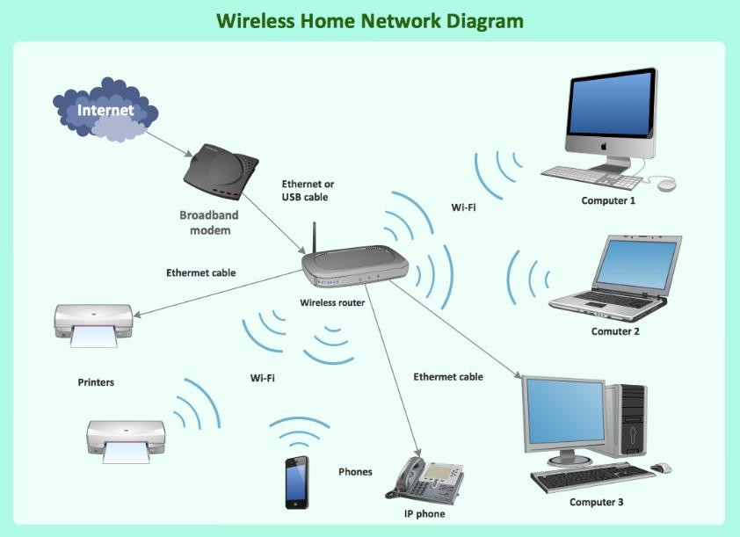

1. **Gate Way:** In a communication network, a network node equipped for interfacing with another network that uses different protocols. A gateway may contain devices such as protocol translators, impedance matching devices, rate converters, fault isolators, or signal translators as necessary to provide system interoperability. It also requires the establishment of mutually acceptable administrative procedures between both networks.
   * A protocol translation/mapping gateway interconnects networks with different network protocol technologies by performing the required protocol conversions.

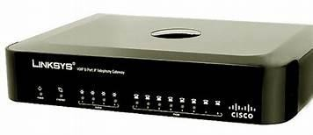

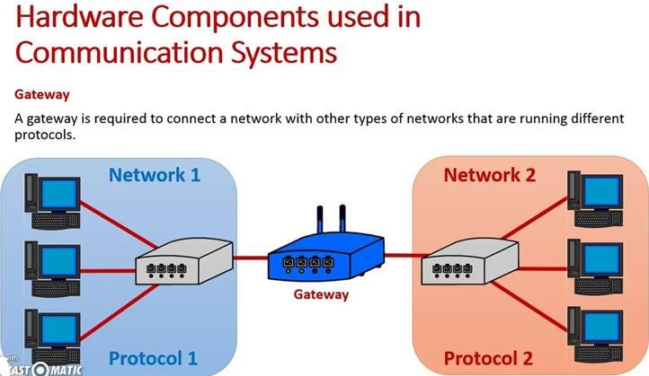

1. Server: A server is a type of [computer](https://www.webopedia.com/TERM/C/computer.html) or [device](https://www.webopedia.com/TERM/D/device.html) on a [network](https://www.webopedia.com/TERM/N/network.html) that manages network [resources](https://www.webopedia.com/TERM/R/resource.html). Servers are often [dedicated,](https://www.webopedia.com/TERM/D/dedicated_server.html) meaning that they perform no other tasks besides their server tasks. On multiprocessing [operating systems](https://www.webopedia.com/TERM/O/operating_system.html), however, a single computer can [execute](https://www.webopedia.com/TERM/E/execute.html) several [programs](https://www.webopedia.com/TERM/P/program.html) at once. A server in this case could refer to the program that is managing resources rather than the entire computer.

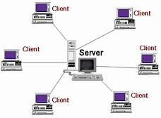

1. **Transmission media**: The medium through which the signals travel from one device to another. These are classified as guided and unguided. Guided media are those that provide a conduit from one device to another. Eg. Twisted pair, coaxial cable etc. Unguided media transport signals without using physical cables. Eg. Air.

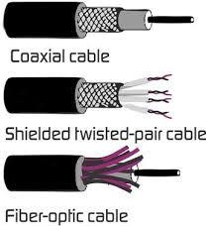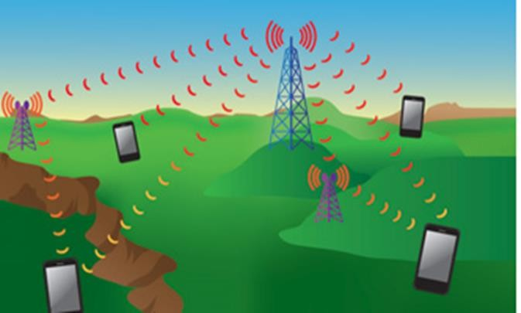

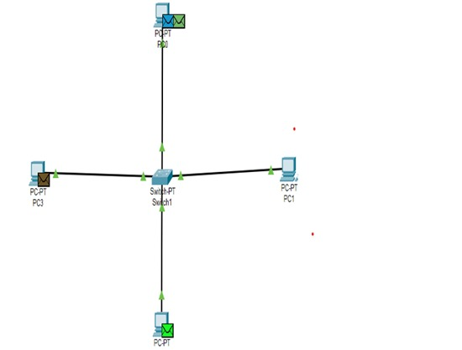

**Result:** Thus the network components are studied in detail.